Institute of Technology, Tralee
Computing Department

Distributed Computing

Remote Procedure Calls (RPC)

Before starting this lab:

1. Install Distinct ONC RPC/XDR Toolkit for Java Version 6. It can be found on the X drive as jrpc-612-tk. Copy to your desktop and run the application. It can also be located at https://www.onc-rpc-xdr.com/products/rpc/rpc-java-xml.asp ONC RPC (formerly calles Sun RPC) is a de-facto RPC standard for Unix. It is included in all major Unix distributions. Microsoft RPC (MS RPC) is a different RPC system and it is interoperable with OSF/DCE RPC. OSF/DCE is also available for nearly al OSs, but usually it is not part of the standard distribution. OSF/DCE RPC is newer and a little bit more powerful than ONC RPC, but for most applications both RPC systems will do the job. ONC RPC and OSF/DCE RPC (and thus MS RPC) are not interoperable at all.
2. Open the Control Panel, then System, Advanced tab, Environment variables and check that the system variable CLASSPATH includes: C:\JRPCv6;C:\JRPCv6\bin\lib\djrpc.jar. This makes the RPC classes available to your Java compiler.

Goal of this lab:
- To understand the theory of RPC and the RPC execution order.
- To understand the different aspects of RPC architecture and what each part contribute to the whole: i.e. XDR IDL, Stubs, XDR, Client, Server
- To know how to write and trace through an RPC program
- To understand ports and portmappers
- To understand gRPC and how it compares to ONC RPC

Read the following descriptions and do the exercises listed.

Exercise 1:

Here is the procedure:

program ECHOPROG {
version ECHOVERS {
int echo(int) = 1;
} = 1;
} = 77;

Write the XDR IDL protocol specification for the echo program above in a file called echo.x in a folder called rpc.

Now, open a command window (as administrator) we will compile the file as follows
> java Jrpcgen –S < echo.x.

This will generate two files, a client stub (ECHOPROG.java) and a server stub
ECHOPROGServer.java. Another name for these types of files are proxies.[Note: stub = proxy]

The Jrpcgen compiler will generate two files for you – a client stub and a server stub.
The client stub is used by the client application to marshall the parameters (i.e. map them to XDR format, and then call the remote procedure across the network.

The server stub will receive the call, unmarshall the parameters and call the actual procedure and return the results to the client.

The diagram below shows what is happening: a) a local procedure b) a remote procedure
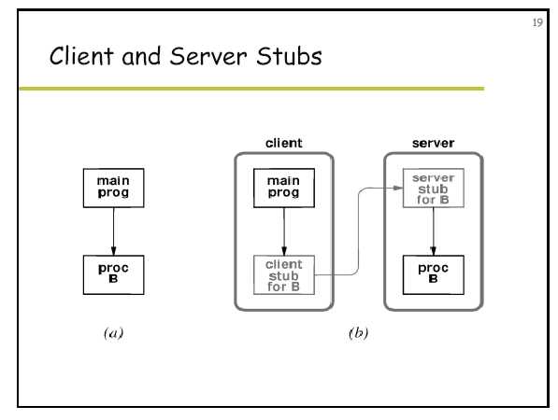

The stubs will interact with the RPC library which will in turn interact with the network layers to send the message.

We will now look at the two stubs which are automatically generated by the compiler.

Exercise 2:
Study the Client Stub code below. Can you see where XDR data mapping is used? Can you see where the actual call to the echo procedure happens?

import com.distinct.rpc.*; // library of RPC classes
import java.io.IOException; // for handling exceptions
import java.net.InetAddress; // for handling network addresses

/**
* This class was automatically generated by Jrpcgen from the RPC/XDR file "echo.x" <br>.
* It defines the client interface to a server implementing the "ECHOPROG" interface.
*/
public class ECHOPROG extends JRPCClient {

/** Program ID of the interface. */
public static final int ECHOPROG = 77;

/**
* CONSTRUCTOR 1 – look at the superclass code as well
* Creates and connects an RPC client for a server that implements the "echo" interface.
* Calls the remote Portmapper in order to get the port of the server.
* @param host The host on which the server lives.
* @param stream true for a TCP connection, false for UDP.
* @exception RPCError When the calls fails for any reason.
*/
public ECHOPROG(InetAddress host, boolean stream) throws RPCError {
super(host, ECHOPROG, ECHOVERS, stream);
}

/**
* CONSTRUCTOR 2
* Creates and connects an RPC client for a server that implements the "echo" interface.
* The client is connected it to a server with a known port. (No interaction with a portmapper)
* @param host The host on which the server lives.
* @param port The port on which the server listens.
* @param stream true for a TCP connection, false for UDP.
* @exception RPCError When the calls fails for any reason.
*/

public ECHOPROG(InetAddress host, int port, boolean stream) throws RPCError {
super(host, ECHOPROG, ECHOVERS, port, stream);
}

/**
* CONSTRUCTOR 3
* Creates an RPC client for a server that implements the "echo" interface.
* It initializes it with a externally created protocol client object.
* @param protocol The protocol object that implements the client connection.
*/

public ECHOPROG(ClientGeneric protocol) {
super(protocol);
}

/** Version ID of the interface. */
public static final int ECHOVERS = 1;

public static final int echo = 1;

/**
* Stub method that invokes the server function "echo" (version 1).
* @param arg1 input parameter of the RPC.
* @return The return value of the RPC.
* @exception java.io.IOException When the RPC fails because the socket connetion fails.
* @exception RPCError When the RPC fails for any other reason.
*/
public int echo_1(int arg1) throws RPCError, IOException {
XDRint arg_ref = new XDRint();
arg_ref.value = arg1;

XDRint retval = new XDRint();

/* now the stub is calls the server stub routine and passes three parameters: the procedure name, the argument and a placeholder for the return value. Can you see where GetClient().Call() comes from and what does it do? Hint – look in class JRPCClient */

GetClient().Call(echo, arg_ref, retval);
return retval.value;
}
}

An instance of this echo stub class represents a client to the echo server i.e. it is the real client of the server. It maintains the complete necessary connection status. Without going into all details we can easily see that this class consists of a number of constants, three constructors, and a public method echo_1() that has the same signature as echo() in the XDR IDL file.
Like all main client-stub classes in Distinct ONC RPC/XDR for Java, the echo class is derived from the base class JRPCClient. This class provides the framework for calling RPC servers using the various possible protocols.

The constants are the program's number and version as well as an ordinal number for each procedure. Of the three constructors the first (public echo(InetAddress host, boolean stream) throws RPCError) is probably the most commonly used one. We will use it in our application example. Finally, the echo_1() method is what we have to invoke when we want to interact with the server. The _1 extension results from the fact that this is the implementation of version 1 of this RPC program. The version number from the XDR file is always appended with an underscore in front of it.

Exercise 3:
Study the Server Stub below. Can you explain what is happening in the DoCall() dispatch routine?

import com.distinct.rpc.*; // RPC library

/**
* <b>ECHOPROG Server Stub</b>
* This class was automatically generated by Jrpcgen from the RPC/XDR file "echo.x.x".<br>
* ECHOPROG: was interface
*/

public abstract class ECHOPROGServer extends JRPCServer {

/** Program ID of the interface. */
public static final int ECHOPROG = 77;

/** Version ID of the interface. */
public static final int ECHOVERS = 1;

public static final int echo = 1;

/**
* CONSTRUCTOR 1
* Constructor that creates the RPC server that implements the "echo" interface.
* @exception RPCError When the calls fails for any reason. The server is registered with the portmapper
*/
public ECHOPROGServer() throws RPCError {
super(ECHOPROG, ECHOVERS, true);

UnregisterServer();
RegisterServer(StartUDP(0), false); // register with the portmapper – parameter 0 means choose a random port
RegisterServer(StartTCP(0), true);
}

/**
* CONSTRUCTOR 2
* Constructor that creates the RPC server that implements the "echo" interface.
* @param port The port on which the server listens (if 0 a random port will be chosen).
* @exception RPCError When the calls fails for any reason.
*/
public ECHOPROGServer(int port) throws RPCError {
super(ECHOPROG, ECHOVERS, true);

UnregisterServer();
RegisterServer(StartUDP(port), false); // register with the portmapper on a particular port
RegisterServer(StartTCP(port), true);
}

/**
* CONSTRUCTOR 3
* Constructor that creates the RPC server that implements the "echo" interface.
* @param port The port on which the server listens (if 0 a random port will be chosen).
* @param do_tcp True, if a TCP server should be started.
* @param do_udp True, if a UDP server should be started.
* @param do_rpcb True, if a RPCBind nameserver should be started (only if there isn't already one running).
* @exception RPCError When the calls fails for any reason.
*/
public ECHOPROGServer(int port, boolean do_tcp, boolean do_udp, boolean do_rpcb) throws RPCError {
super(ECHOPROG, ECHOVERS, do_rpcb);

UnregisterServer();
if (do_udp) RegisterServer(StartUDP(port), false);
if (do_tcp) RegisterServer(StartTCP(port), true);
}

/**
* This is the dispatch routine. It is called from the RPC library on the server. Look at the JRPC *class in the documentation

* @param proc The index of the requested function.
* @param xin read the input-parameter from this XDR stream.
* @param xout write the return-parameter to this XDR stream.
* @return true, if the function with the index proc can be served, false otherwise.
*/
public boolean DoCall(int proc, XDRStream xin, XDRStream xout) {
try {

switch (proc) {
case echo: {
int arg = xin.xdr_decode_int();
int ret = echo_1(arg);
xout.xdr_encode_int(ret);
return true;
}

default:
break;
}

return (proc==0)?true:false;

}
catch (Exception e) {
return false;
}
}

/*
* Overwrite these abstract server methods for implementing the server's functionality.
*/

public abstract int echo_1(int arg1); // NO IMPLEMENTATION PROVIDED
}

Like all server stub classes in Distinct ONC RPC/XDR for Java, the class echoServer is derived from the base class JRPCServer. This class provides the framework for implementing RPC servers using the various possible protocols. The constants are the program's number and version and ordinal numbers for the remote procedure.

The method DoCall() is the core of the server. It implements dispatching of the remotely called procedures depending on the given ordinal number and it calls marshalling and unmarshalling of the parameters.

Finally, the abstract echo_1() method is the procedure we have to implement for our echo server by overriding it in a derived class.

Now we must write a Client and a Server ourselves:

Exercise 4:
Write the client code below and save it in echoclient.java. Can you see where the client creates an instance of the stub and calls the echo procedure?

// echoclient.java
import java.net.*; // network classes

public class echoclient
{
public static void main(String[] argv)
{
ECHOPROG client; // client is an instance of echo class (i.e. the stub)
if(argv.length <2)
{ System.out.println("Usage: java echoclient host number");
System.exit(0);
}
try
// call echo method in the stub
{ client = new ECHOPROG(InetAddress.getByName(argv[0]),true); int result = client.echo_1(Integer.parseInt(argv[1]));
System.out.println("\nThe Echo Number is " + result);
}
catch(Exception e)
{
System.out.println("\nThe Exception is " + e.getMessage());

}
System.exit(0);
}
}

First we import java.net.* since we need at least the InetAddress class to talk to the server.
In this example we do not import the generated demo stub class, as we assume it is in the same package (in this case the default package). Of course, if this is not the case, we have to import it as well (i.e. import echo)
We then define a very simple class echoclient with just the static main() method. main() interprets the first string parameter from the command line as the name of the host where the echo server is running and the second argument is the integer passed to the server.

Next we open an exception context. Most of the Distinct ONC RPC/XDR for Java methods throw either a RPCError or an IOException.

Please note that every time this occurs, the status of the used client object is undefined. If this happens, you should reestablish the connection with a new client object if you want to call the server again. In our sample program we just catch every exception and print the message on the screen.
Now we declare an object of class echo. This is the client object we use every time we call the echo server.
Now, we establish the connection to the server by calling the simplest constructor of the echo client class. Parameters are the hostname of the server (from the command line) and a boolean that indicates whether we want to set up a TCP or a UDP connection. A value of true means TCP.
If this call does not throw an exception we are connected. Depending on whether the addressed host really has a ONC RPC portmapper and a echo server running, it may take several seconds before the success or the failure of this call are reported.
Once we are connected to the server we call the echo_1() procedure.
This is our first RPC client written in Java.

Exercise 5:
Now we must write a server which implements the echo_1() procedure. Write the following code and save it in MyServer.java

// myServer.java
import com.distinct.rpc.*; // RPC libraries

public class MyServer extends ECHOPROGServer
{
public static void main(String[] args)
{
try
{ new MyServer(); // creates an instance of the Server stub
}
catch (RPCError e)
{ System.out.println(e.getMessage());
}
}

public MyServer() throws RPCError
{ super();
}
// override the echo_1 method from the stub – where it does nothing
public int echo_1(int a)
{
return(--a);
}
}

The server code defines a new class named MyServer that is derived from the echoServer class and that finally implements the remote procedure echo_1() in a straightforward manner.
The main() method is not defined by the automatically generated stub but by the implementing class. The only thing main() does, is create a MyServer server object and handle the possible RPCError exception.
Note that the implementation of the echo function has an “_1” appended to its name. In general, all remote procedures called by Jrpcgen are named by the following rule: the name in the program definition (i.e. in the XDR IDL file: echo) is converted to all lower-case letters, an underbar (“_”) is appended to it, and finally the version number (here 1) is appended.

Exercise 6
compile the application
>javac echoclient.java
>javac MyServer.java

run the Server in a window:
>java myServer

run the client in another window
>java echoclient localhost [number]

RPCBIND
Every server must be attached to a port number.

The portmapper kept a table of the servers and their ports

Basically, RPCBIND is a name server. Server ports of ONC RPC servers are chosen randomly. It is the responsibility of RPCBIND to tell the clients the port number of a server with a given program/version number.
You will need an instance of the RPCBIND (or Portmapper) running on each machine that hosts ONC RPC servers. It is required to bind RPC clients to servers.

RPCBIND itself is an RPC server that listens on a well-known port (111) for these requests.

Typically, RPCBIND or Portmapper is running as a demon in the background and it is usually provided by the standard ONC RPC infrastructure that is part of e.g. any network connected UNIX host (e.g. NFS relies on ONC RPC). However, if you are starting your RPC server on a machine that does not provide this infrastructure by default (e.g. all flavors of MS Windows) you have to make sure that RPCBIND is present to enable clients to connect to your new server.
The Distinct ONC RPC/XDR for Java Toolkit provides its own implementation of the RPCBIND. This pure Java implementation of the RPCBIND implements the RPCBIND protocol versions 3 and 4 as well as the portmap interface version 2.

As RPCBIND uses a fixed port number (111) there can be only one RPCBIND or Portmapper instance per node. Therefore, any server that uses the Jrpcgen generated stub will first check, whether the system already provides RPCBIND, and if not, it will start its own RPCBIND.

Please note, that all ONC RPC servers that are subsequently started on that node will now also use this instance of RPCBIND. This means, if you shut down the Distinct ONC RPC/XDR for Java server that started RPCBIND, you will also loose the ability to bind new clients to the other, still running servers, as the portmapper that stores the binding information is gone.

Connections that were established before RPCBIND went down are not affected, as the binding is established only once during the connection setup. You can avoid this by starting the RPCBIND or the portmapper manually before starting the server.
To check whether RPCBIND or a Portmapper is running you can use the standard ONC RPC rpcinfo tool with the -p <hostname> option. This should enumerate the servers registered with the portmapper of this host. If this tool reports an error or does not show the servers you were expecting, there is obviously a problem with the Portmapper.
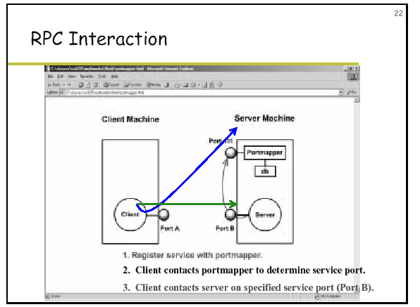

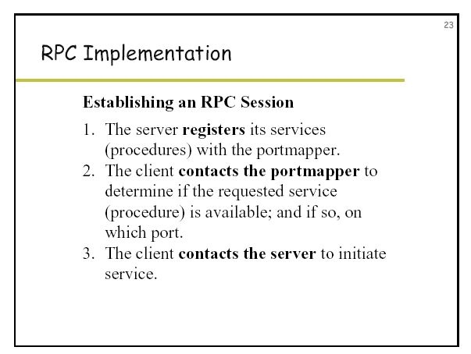

Exercise 7:
While you have a server running, run the rpcinfo program in C:\Program Files (x86)\Distinct\JRPCv6\bin\ Change to this directory and run the program from the command line:
- java RPCInfo
Can you see the port on which your server is running (remember the program has the code number 77) . This is the information stored on the portmapper on the server. The client will need to access this information before it can connect to a server.

Exercise 8
Try to contact a server on another machine running in the lab (you can discover your own IP number using ipconfig from the command line). You will need to get the IP number of another machine that is running a server that was defined by the same XDR IDL file as your own client.

Question 1: is access to the server transparent to the user of the client?
Question 2: Why does the XDR IDL file have to be the same on your client and on the other server?

Exercise 9:
Write a java RPC program which will reverse a word passed to the Server

Exercise 10:
Goto https://grpc.io/ and read about gRPC
Download and run the Java gRPC quickstart program at https://grpc.io/docs/quickstart/java.html

Learning outcomes Test yourself - What you should know after this lab:
What is RPC? (very important)
What is the ONC RPC/XDR Toolkit for Java Version 6
Describe the RPC execution order (very important)
Know how to use Jrpcgen – what files are input and what files are output
What do stubs do? (very important)
What is XDR IDL? (very important)
What problems can occur when transferring data from one machine to another – how does XDR solve the problems? (very important)
Know how to write an IDL file and how to complete an RPC application by writing a client and a server
What is the portmapper – what are static ports?
What is gRPC and how does it compare to ONC RPC?

